Documentation

**MVC pattern**

First of all the application is using as the overall architecture the MVC pattern because it is using a Model a View and a controller

Model:



View:

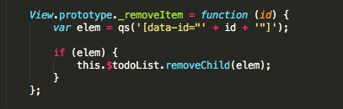

Controller:

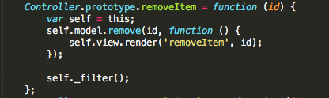

**No Framework:**

All the application is done with JavaScript so no framework is used.

**Observer pattern :**

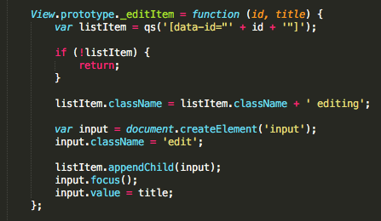

**Command Pattern:**

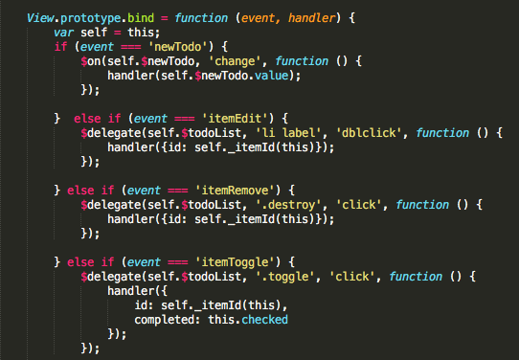

A **Factory Pattern** must be used to create new tasks:

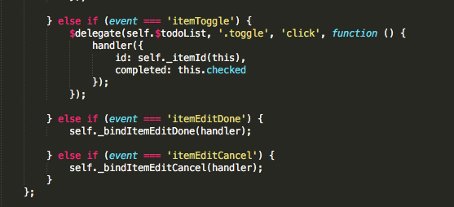

The **Iterator pattern** must be implemented to run through the tasks:

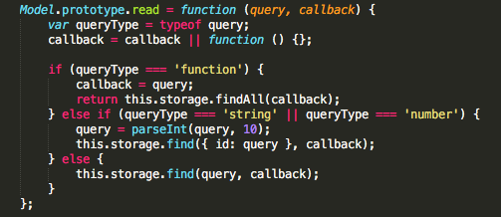

Finally to run the application in a windows Pc you need to download and unzip the Taskmanager.app then move to Contents then Resources then app and finally main.

It is recommended to open the app in a Chrome Browser.